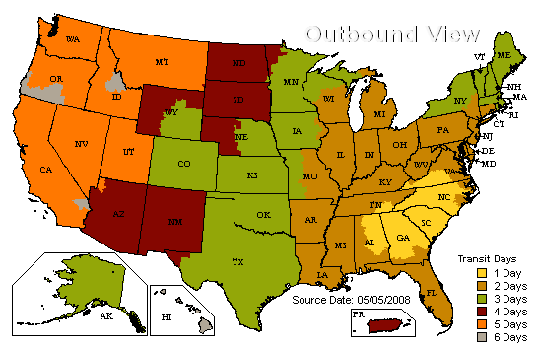
UnitedScrip Shipping Schedule
UnitedScrip is located in South Carolina (Gold Area) and ships UPS. Please refer to chart for the expected shipping times and to determine how you would like your packages shipped to your Group or Organization. Special Rates may apply for Next Day Service. Orders are shipped in order received and under normal circumstances are shipped the same day*.
(*Exceptions occur during the busy holiday season from November 20 – December 20. Please plan for one additional day to receive your order.)
- UPS Ground - Residential $8.50 (Signature Required)
- UPS Ground – Business/School $7.50 (Signature Required)
- 2nd Day Air AM By quote
- 2nd Day Air – Residential $12.50 (Signature Required)
- 2nd Day Air - Business/School $10.50 (Signature Required)
*Waiver must be signed for packages left without signature. UnitedScrip can not be responsible for lost or stolen gift cards left without signatures!
**Please note that rates reflect shipping costs that include partial payment of costs paid by UnitedScrip. It is not our intention to profit from shipping; we will gladly adjust if possible!

Helpful Hints

- Orders received by 2 pm ET will be processed for shipping that day. Any orders received after 2 pm ET cannot be guaranteed for same day shipping.
- Order Additions – if you need to add to your order, please inform UnitedScrip of your existing order and Invoice # when making the addition. This will enable us to combine shipments if possible. The additional order will be invoiced separately. Please Note: If the addition is received after 2 pm, we cannot guarantee that it will be shipped with the original order.
- All orders must include your group name and contact information, including a phone number so that we may confirm your order or address any questions we may have concerning that order.
- Email all orders to orders@unitedscrip.com

Procedures that you need to know!

- We always acknowledge your emailed order with a “Thanks for ordering from UnitedScrip.” reply. If you do not receive this confirmation, call to make sure the email was properly transmitted. (Program Hint: Always email a copy of your order to an email address you can access from home or have access to after you leave the computer that contains your software.)
- If you fax an order, please call to make sure that it was received.
- After the order is filled, a pdf. copy of your invoice is emailed to you. Check the invoice for accuracy and call immediately if there is an error. Backorders will be noted and moved to a backorder invoice. (We do not ACH any backorders until they are shipped!)
- At the end of the day, you will receive an email from UPS Quantum View [QuantumViewNotify@ups.com] containing a UPS tracking number for your package.
- For delayed packages, please contact UPS to receive information. To speak to an operator call 1.800.742.5877 (1.800.PICKUPS) or for detailed information visit http://www.ups.com/content/us/en/index.jsx Enter your tracking number.

